
FACULTY OF ENGINEERING AND TECHNOLOGY

COURSE UNIT; COMPUTER PROGRAMMING

LECTURER: MR MASERUKA BENDICTO

COURSES; AMI, APE, WAR, MEB
GROUP 8

GROUP 8 MEMBERS
NAME | COURSE | REG NUMBER | SIGN
LWASAMPIJJA ASHIRAF | AMI | BU/UP/2024/5253
AUJO EVERLYN | AMI | BU/UP/2024/3223
RUBANGAKENE GEOFFREY | WAR | BU/UP/2024/3260
BINYWERA NICHOLAS | WAR | Bu/up/2024/3249
KAKUMBA ISSAC SSEMBOGO | WAR | BU/UP/2024/2593
ADIKINI BEATRICE | WAR | BU/UP/2024/4090
APIO MARY GRACE | WAR | BU/UP/2024/3247
OJABAN NELSON | AMI | BU/UP/2024/3226
KOMUHANGI AGATHA | AMI | BU/UP/2024/3735

DATE OF SUBMISSION: ………………………………
SUBMITTED TO: …………………………………
SIGNATURE: ……………………………………………..

ABSTRACT

This report represents a comprehensive analysis of various numerical methods employed to solve mathematical problems, their applications in real life and practical examples conducted by a collaborative group of six individuals. We employed both traditional hand calculations techniques and modern programming approaches like Matla to enhance our understanding of numerical analysis. The methods investigated include the Newton Raphson method, fixed point iteration, bisection method, secant and langrage method.
Each member contributed to the development and implementation of these techniques, allowing for a comparative assessment of accuracy, efficiency and ease of use.

DECLARATION

We hereby declare that the work presented in this report is our original work and has not been submitted for any other academic purpose. This report is a result of our own research and understanding of the numerical methods, formulation, implementation and applications.

ACKNOWLEDGEMENT

We would like to begin by expressing our heartfelt gratitude to Almighty God for granting us wisdom, strength and perseverance needed to complete this report
We also appreciate the collaborative spirit of our team members and all those who contributed to the successful completion of this report on numerical analysis.

DEDICATION

We dedicate this report to all the inspiring mathematicians and engineers who strive to unlock the mysteries of numerical methods. May this inspire you to pursue knowledge with passion and determination.

LIST OF ABBREVIATIONS

AMI – Agricultural mechanization

WAR- Water resources engineering

APE – Agroproccessing engineering

MEB – Mining Engineering

Table of Contents
ABSTRACT 3
ACKNOWLEDGEMENT 5
DEDICATION 6
LIST OF ABBREVIATIONS 7
INTRODUCTION 9
METHODOLOGY 9
STUDY COVERAGE 9
ITERATION METHODS 9
Newton-Raphson Method 9
Secant Method 12
REAL WORLD PROBLEM 16
WHAT THE CODE DOES 16
graphs 18
PART B: NUMERICAL METHODS FOR Odes 19
CONCLUSION 22
RECOMMENDATION 23
REFERENCES 24

INTRODUCTION

METHODOLOGY
The information in this group report was achieved and collected through different preparations. It aims to explore the various numerical methods used in programming and their practical applications in solving real-life engineering problems. By examining real-world examples, we will explain the effectiveness of these methods, providing insights into their role in advancing engineering practices. Through collaborative research and analysis, we hope to contribute to a deeper understanding of how numerical methods can be harnessed to tackle contemporary engineering challenges.

STUDY COVERAGE
The purpose of the study was to enable students appreciate how crucial numerical methods are in approximating solutions to mathematical problems that can not be solved analytically.
This is especially true in engineering, where real world scenarios often involve complex equations.

ITERATION METHODS

Newton-Raphson Method
Use Newton’s Raphson method to find the root of the equation 𝑥³ + 𝑥 − 1 = 0, using 𝑥₀ =
0.5 as the initial approximation, correct your answer to 2 dps.

𝑓(𝑥) = 𝑥³ + 𝑥 − 1

𝑓′(𝑥) = 3𝑥² + 1
𝑓(𝑥_{𝑛})
𝑥𝑛+1 = 𝑥𝑛 − 𝑓′(𝑥 )
𝑛

Equation 1 Shows the Newton's Raphson Formula
2𝑥_{𝑛}³ + 1

𝑥𝑛+1 = 3𝑥
𝑛
2 + 1

𝑥₀ = 0.5

2(0.5)³ + 1
𝑥1 = 3(0.5)² + 1

𝑥₁ = 0.7142

2(0.7142)³ + 1
𝑥2 = 3(0.7142)² + 1

𝑥₂ = 0.6831

2(0.6831)³ + 1
𝑥3 = 3(0.6831)² + 1

𝑥₃ = 0.6824

|0.6824 − 0.6831| < 0.005

Root is 0.68

Pseudocode:
clc; clear; close all;
% Function (height of projectile)
v0 = 20; g = 9.81;
f = @(t) v0*t - 0.5*g*t.^2;
fprime = @(t) v0 - g*t; % derivative for Newton-Raphson

% Exact solution (impact time)
t_exact = 2*v0/g;

% Parameters
tol = 1e-6; maxIter = 100;
a=1; b=5; % interval containing root
x0=2; % initial guess

methods = {'Bisection','False Position','Newton-Raphson','Secant'};
roots_found = zeros(1,length(methods));
times = zeros(1,length(methods));

Algorithm NewtonRaphson(f, fprime, x0, tol, maxIter)
1. Set x = x0
2. For i = 1 to maxIter
x_new = x - f(x) / fprime(x)
If |x_new - x| < tol then
root = x_new
Stop
End if
x = x_new
3. End For
4. Return x as root
Flowchart:

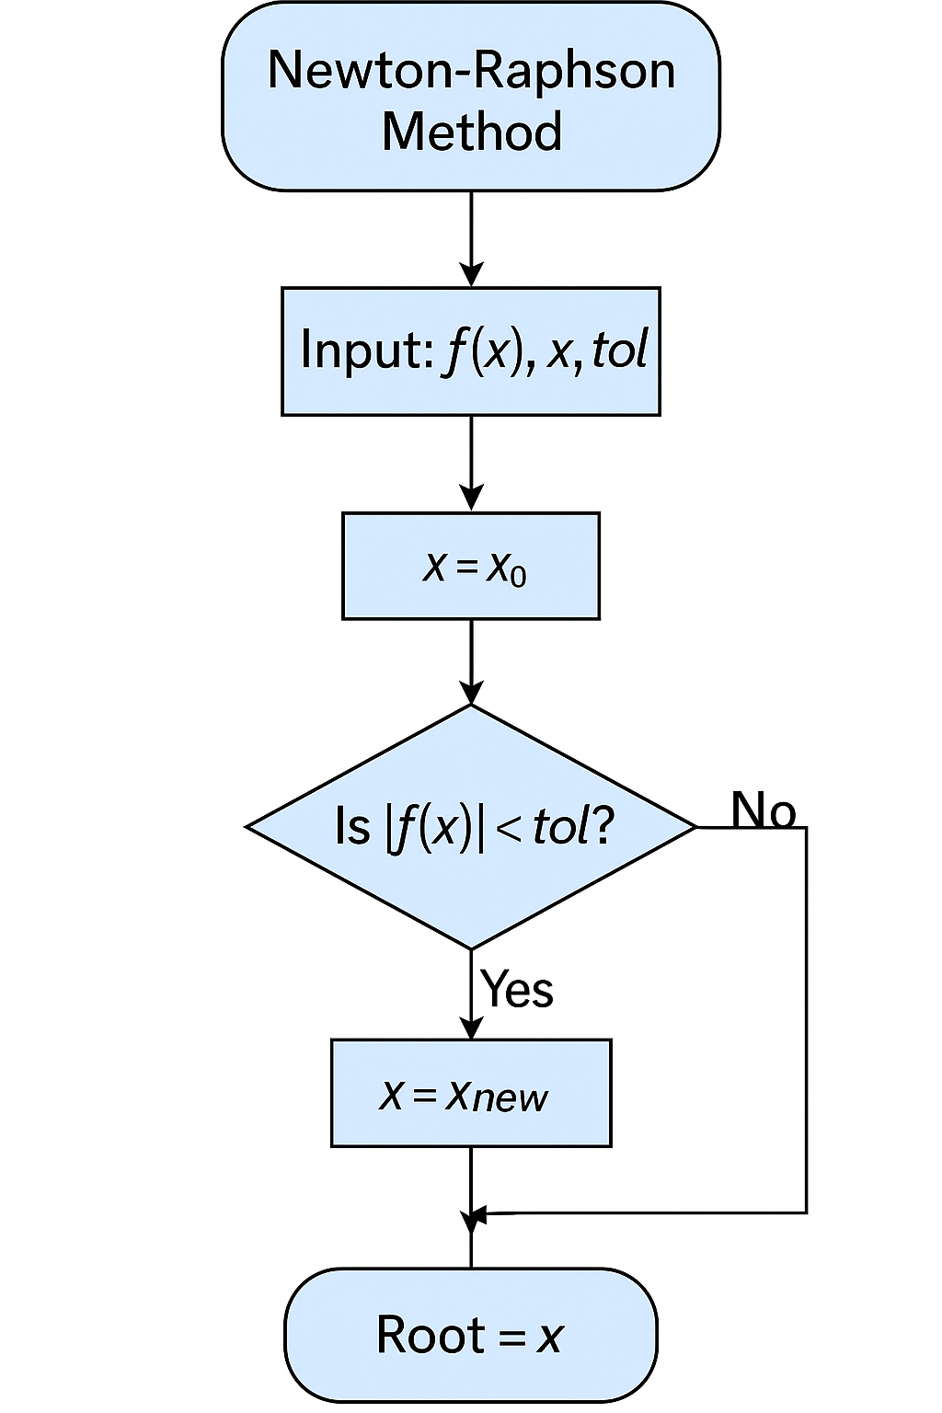

Matlab code
%%NEWTON RAPHSON METHOD

% funtion
f=@(x)x^3-4*x-9;
% differentiation
df=@(x)3*x^2-4;
% other given values
e=10^-6;
x0=0;
n=10;
tic;

%SOLUTION

if df(x0~=0)
for i=1:n
x1=x0-f(x0)/df(x0);
x0=x1;
end
else
disp('Newton raphson method failed')
end
timetaken=toc;

Secant Method
Pseudocode:
%% Secant Method
tic;
x0=1; x1=5;
for i=1:maxIter
x2 = x1 - f(x1)*(x1-x0)/(f(x1)-f(x0));
if abs(x2-x1)<tol, break; end
x0=x1; x1=x2;
end
roots_found(4)=x2; times(4)=toc;

Algorithm Secant(f, x0, x1, tol, maxIter)
1. For i = 1 to maxIter
x2 = x1 - f(x1) * (x1 - x0) / (f(x1) - f(x0))
If |x2 - x1| < tol then
root = x2
Stop
End if
x0 = x1
x1 = x2
2. End For
3. Return x2 as root
Flow chart;
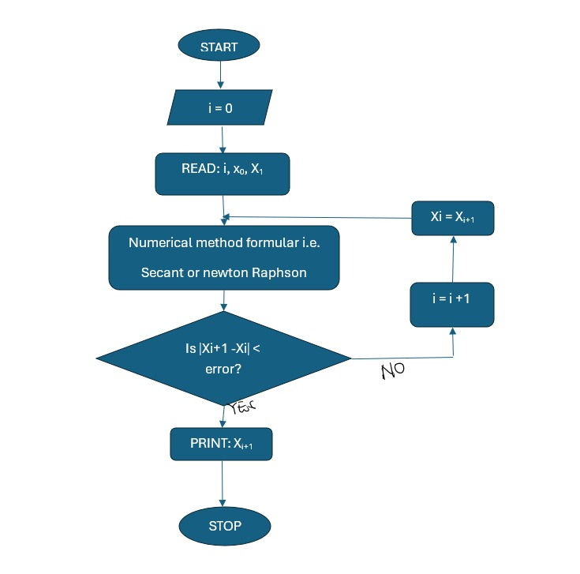

Fixed Point Iteration
Pseudocode:
% function
f=@(x) (2^x+2)/5;
x0=0;
e=0.0001;
n=10;
tic;

SOLUTION

for i=1:n
x1=f(x0)
fprintf('x%d=%4f\n',i,x1)
if abs(x1-x0)<e
end
x0=x1;
end
x1 = 0.6000
x1=0.600000
x1 = 0.7031
x2=0.703143
x1 = 0.7256
x3=0.725610
x1 = 0.7307
x4=0.730720
x1 = 0.7319
x5=0.731893
x1 = 0.7322
x6=0.732163
x1 = 0.7322
x7=0.732226
x1 = 0.7322
x8=0.732240
x1 = 0.7322
x9=0.732243
x1 = 0.7322
x10=0.732244
timetaken=toc
timetaken = 0.0211

Algorithm FixedPoint(g, x0, tol, maxIter)
1. For i = 1 to maxIter
x_new = g(x0)
If |x_new - x0| < tol then
root = x_new
Stop
End if
x0 = x_new
2. End For
3. Return x_new as root
MATLAB CODE
%%FIXED POINT ITERATION
%FIXED POINT ITERATION

% annonymous function()
f=@(x) (2^x+2)/5;
x0=0;
e=0.0001;
n=10;
tic;

%5SOLUTION

for i=1:n
x1=f(x0);
fprintf('x%d=%4f\n',i,x1)
if abs(x1-x0)<e
end
x0=x1;
end
timetaken=toc;

REAL WORLD PROBLEM

WHAT THE CODE DOES
• Models projectile motion height function.
• Finds the impact time (non-trivial root) using:
- Bisection
- False Position
- Newton-Raphson
- Secant
• Compares against the exact analytical solution.
• Plots:
- Function with roots marked
- Bar chart of runtimes
• Displays error values and computation times in the command window

MATLAB CODE

clc; clear; close all;

% Function (height of projectile)
v0 = 20; g = 9.81;
f = @(t) v0*t - 0.5*g*t.^2;
fprime = @(t) v0 - g*t; % derivative for Newton-Raphson

% Exact solution (impact time)
t_exact = 2*v0/g;

% Parameters
tol = 1e-6; maxIter = 100;
a=1; b=5; % interval containing root
x0=2; % initial guess

methods = {'Bisection','False Position','Newton-Raphson','Secant'};
roots_found = zeros(1,length(methods));
times = zeros(1,length(methods));

%% Bisection Method
tic;
a1=a; b1=b;
for i=1:maxIter
c=(a1+b1)/2;
if abs(f(c))<tol, break; end
if f(a1)*f(c)<0, b1=c; else a1=c; end
end
roots_found(1)=c; times(1)=toc;

%% False Position Method
tic;
a1=a; b1=b;
for i=1:maxIter
c=(a1*f(b1)-b1*f(a1))/(f(b1)-f(a1));
if abs(f(c))<tol, break; end
if f(a1)*f(c)<0, b1=c; else a1=c; end
end
roots_found(2)=c; times(2)=toc;

%% Newton-Raphson Method
tic;
x=x0;
for i=1:maxIter
x_new = x - f(x)/fprime(x);
if abs(x_new-x)<tol, break; end
x=x_new;
end
roots_found(3)=x_new; times(3)=toc;

%% Secant Method
tic;
x0=1; x1=5;
for i=1:maxIter
x2 = x1 - f(x1)*(x1-x0)/(f(x1)-f(x0));
if abs(x2-x1)<tol, break; end
x0=x1; x1=x2;
end
roots_found(4)=x2; times(4)=toc;

%% Display results
fprintf('\nProjectile Motion Root-finding Comparison:\n');
for i=1:length(methods)
fprintf('%s: root = %.6f, time = %.6e s, error = %.2e\n', ...
methods{i}, roots_found(i), times(i), abs(roots_found(i)-t_exact));
end
fprintf('Exact solution: %.6f s\n', t_exact);

%% Plot function and roots
t_vals=linspace(0,5,200);
figure;
plot(t_vals,f(t_vals),'b','LineWidth',2); hold on;
yline(0,'k--');
plot(roots_found,zeros(size(roots_found)),'ro','MarkerSize',8,'MarkerFaceColor','r');
plot(t_exact,0,'gs','MarkerSize',10,'MarkerFaceColor','g');
legend('f(t)','y=0','Approx roots','Exact root');
xlabel('t (s)'); ylabel('f(t)'); title('Projectile Motion Root-Finding');
grid on;

%% Bar chart of computation times
figure;
bar(categorical(methods),times);
ylabel('Time (s)'); title('Computation Times of Methods');

graphs
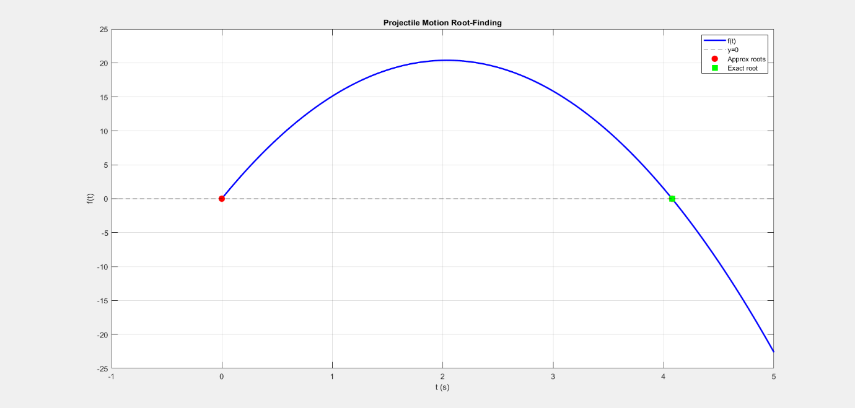

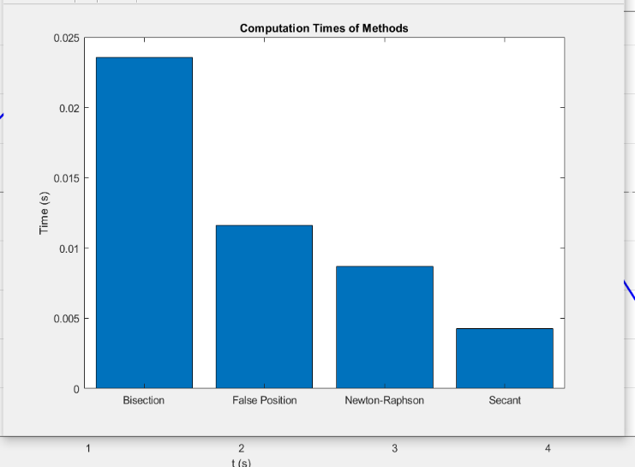

PART B: NUMERICAL METHODS FOR Odes
We will solve with:
- Euler’s Method
- Improved Euler (Heun’s Method)
- Runge-Kutta 4 (RK4)
- (Optional) Adams-Bashforth or ode45 (MATLAB inbuilt)
Pseudocode (Euler’s Method)
Algorithm Euler(f, t0, y0, h, N)
1. Set t = t0, y = y0
2. For i=1:N
y(i+1) = y(i) + h * f(t(i), y(i))
t(i+1) = t(i) + h
3. Return( t, y)

FLOW CHART

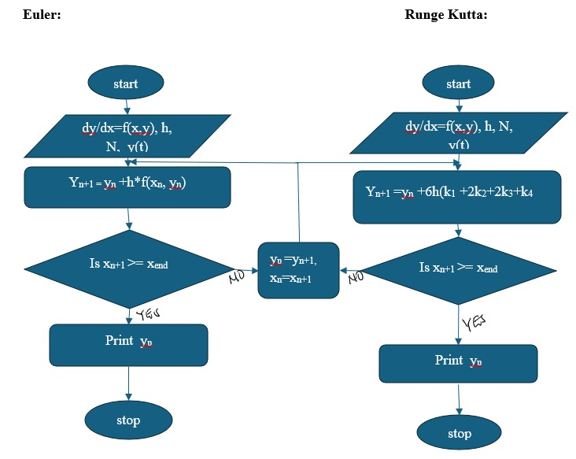

MATLAB CODE

clc; clear; close all;

f = @(t,y) -2*y;
t0=0; tf=2; y0=1;
N=20; h=(tf-t0)/N;
t=t0:h:tf;

%% Euler
tic;
y_euler=zeros(size(t)); y_euler(1)=y0;
for i=1:N
y_euler(i+1)=y_euler(i)+h*f(t(i),y_euler(i));
end
time_euler=toc;

%% Heun (Improved Euler)
tic;
y_heun=zeros(size(t)); y_heun(1)=y0;
for i=1:N
k1=f(t(i),y_heun(i));
k2=f(t(i)+h,y_heun(i)+h*k1);
y_heun(i+1)=y_heun(i)+h*(k1+k2)/2;
end
time_heun=toc;

%% RK4
tic;
y_rk4=zeros(size(t)); y_rk4(1)=y0;
for i=1:N
k1=f(t(i),y_rk4(i));
k2=f(t(i)+h/2,y_rk4(i)+h*k1/2);
k3=f(t(i)+h/2,y_rk4(i)+h*k2/2);
k4=f(t(i)+h,y_rk4(i)+h*k3);
y_rk4(i+1)=y_rk4(i)+h*(k1+2*k2+2*k3+k4)/6;
end
time_rk4=toc;

%% Analytical Solution
y_exact=exp(-2*t);

%% Plot results
figure;
plot(t,y_exact,'k','LineWidth',2); hold on;
plot(t,y_euler,'--r','LineWidth',1.5);
plot(t,y_heun,'--b','LineWidth',1.5);
plot(t,y_rk4,'--g','LineWidth',1.5);
legend('Exact','Euler','Heun','RK4');
xlabel('t'); ylabel('y(t)');
title('Numerical vs Analytical Solution');
grid on;

%% Display times
fprintf('Computation times:\nEuler: %.6e s\nHeun: %.6e s\nRK4: %.6e s\n', ...
time_euler,time_heun,time_rk4);

CONCLUSION
- While the secant method can be faster than other methods in certain scenarios, its important to note that its performance can depend on the choice of the initial guesses and the nature of the function being analysed. Each method has its strengths and weakness, making them suitable for different types of problems.

RECOMMENDATION
- We recommend Engineers to assess the characteristics of their specific problem before choosing the most suitable numerical method for their solution.

REFERENCES
- Numerical methods for Scientific and Engineering Computation (R.K. Jain) Introduction to numerical analysis (Josef Stoer)
- The art of scientific Computing (William. H. Press) Numerical Methods for Engineers (Steven C. Chapra)
- Conte Samuel D. & Carl de Boor: Elementary N A and Algorithmic Approach 3rd edition 2005.
- Financial Modelling with MATLAB by Robert Tatman

